IPL Data Mining: Performance Trends of Teams and Players

Kumar Saurav
Computer Science and Engineering
Bennett University
Uttar Pradesh, India
s24cseu2576@bennett.edu.in

⭐ Abstract
The Indian Premier League (IPL) is more than just a cricket tournament—it’s a massive source of data that captures every ball, run, wicket, and decision made on the field. In this project, I explored IPL datasets to understand how teams and players perform across seasons. Using Python along with libraries like Pandas, NumPy, Matplotlib, and Seaborn, I cleaned and analysed match-level and ball-by-ball data from the matches.csv and deliveries.csv files. The goal was to uncover meaningful patterns such as which teams win the most, which batsmen score consistently, how toss decisions affect match results, and how performance varies across venues. By applying data preprocessing, grouping, and visualization techniques, I was able to highlight trends in run scoring, strike rates, dismissal types, and winning strategies.
This project shows how data analysis can offer a deeper understanding of the IPL, revealing insights that are not immediately obvious just by watching matches. The findings demonstrate how data can help evaluate performance, compare players, and understand the key factors behind success in the tournament.
Keywords -- IPL Data Analysis, Sports Analytics, Player Performance, Data Visualization, Python Programming, Match Statistics, Team Performance

I. INTRODUCTION
Cricket is more than just a sport in India—it is a cultural phenomenon that brings people together with passion and excitement. Among all cricket events, the Indian Premier League (IPL) stands out as one of the most dynamic and widely celebrated tournaments, featuring world-class players, fast-paced matches, and unpredictable outcomes. With each season, the IPL produces an enormous amount of data, including match details, player statistics, ball-by-ball actions, and team strategies. This makes the IPL dataset an ideal source for applying data analysis and uncovering deeper insights about the game.
In recent years, data-driven analysis has become an essential part of sports decision-making. Teams, analysts, and broadcasters often rely on statistical models and visual analytics to evaluate player performance, plan match strategies, and understand how various factors influence the outcome of a match. Motivated by this growing trend, this project explores IPL data from multiple seasons to reveal underlying performance patterns, identify consistent players, study match-winning factors, and highlight how different conditions affect results.
Using Python along with data-science libraries such as Pandas, NumPy, Matplotlib, and Seaborn, this project analyses two major datasets—matches.csv and deliveries.csv. These datasets cover everything from match summaries to ball-by-ball details. After performing data cleaning and preprocessing, various statistical methods are applied to understand batting trends, bowling effectiveness, team consistency, toss impact, venue influence, and season-wise scoring patterns.
A major strength of this project is the use of tables and charts to present insights clearly and visually. Tables are used to summarize important statistics such as top run scorers, most successful teams, and player dismissals. Charts—including bar graphs, line plots, histograms, heatmaps, and pie charts—help visualize patterns that are difficult to notice otherwise. These visual elements make the analysis easier to understand and reveal meaningful trends at a glance.
In summary, this project demonstrates how IPL, beyond being an exciting cricket league, also provides a rich dataset for performing practical data analysis. Through structured exploration, visualizations, and statistical interpretation, this project highlights how data can tell the story of players, teams, and strategies. The insights discovered here not only deepen our understanding of the IPL but also showcase the real-world power of data analytics in sports.
II. PROPOSED SYSTEM
The proposed system aims to analyse IPL match and ball-by-ball data using a structured and data-driven approach. The system is designed to take raw cricket datasets, preprocess them, extract meaningful statistical patterns, and present those insights through tables and visual charts.
The system begins by loading two datasets: matches.csv and deliveries.csv. These are imported into Python using Pandas, which allows efficient handling of large data. Once loaded, the data undergoes cleaning steps such as removing missing values, fixing incorrect data types, merging datasets where necessary, and creating new calculated fields like strike rate, match totals, and dismissal counts.
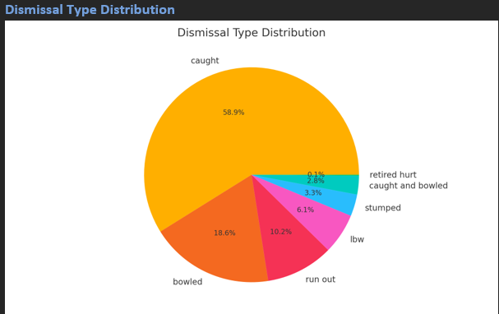
After preprocessing, the system performs grouped analysis to extract meaningful summaries — such as total runs scored by each batsman, number of matches won by teams, dismissal patterns, and season-wise performance. Additional metrics like strike rate, batting averages, and win counts are computed to better understand player and team behaviour.
Visualization tools such as Matplotlib and Seaborn play a major role in the proposed system. These tools convert large volumes of data into easy-to-understand charts, including bar graphs, pie charts, line plots, and histograms. These graphical outputs help highlight trends that would otherwise remain hidden in raw numbers.
The proposed system therefore acts as a complete workflow — from raw data collection to cleaning, analysis, visualization, and insight generation. By combining statistical methods with visual storytelling, this system helps reveal deep patterns in IPL performance and supports data-driven understanding of the game.
⭐ Dataset Preprocessing
Before analysing the IPL data, it was important to make sure the dataset was clean, consistent, and properly structured. Raw data coming from large sports datasets often contains missing values, duplicate entries, formatting issues, and extra information that is not useful for the analysis. So, the first major step in this project was preprocessing the data to prepare it for accurate results.
I started by loading the two datasets, matches.csv and deliveries.csv, using Pandas. Once the data was imported, I examined the shape, column structure, and initial rows to understand what kind of information each file contained. This helped identify which columns were essential for analysis and which ones needed cleaning or removal.
One of the common issues in the dataset was missing values. For example, some matches did not have a recorded city or certain umpire names. These values were either filled appropriately or ignored depending on their importance. Columns that contained too many missing or irrelevant entries were removed to keep the dataset clean and focused.
The next step was correcting inconsistent data types. Several columns—such as match identifiers, overs, and ball numbers—were stored as strings even though they represented numerical information. These were converted into appropriate numerical formats. Similarly, columns such as team names, player names, and dismissal types were converted into categorical data to make grouping and analysis much faster.
Unnecessary columns that did not contribute to the project objectives were dropped. This included fields like umpire details and other administrative information that had no connection to performance analysis. Removing such columns reduced noise and made the dataset more efficient to work with.
After cleaning individual datasets, I performed merging operations whenever deeper relationships were needed. For example, the match_id column was used to connect match-level information to ball-by-ball data. This allowed the project to calculate totals, averages, and performance indicators across both datasets seamlessly.
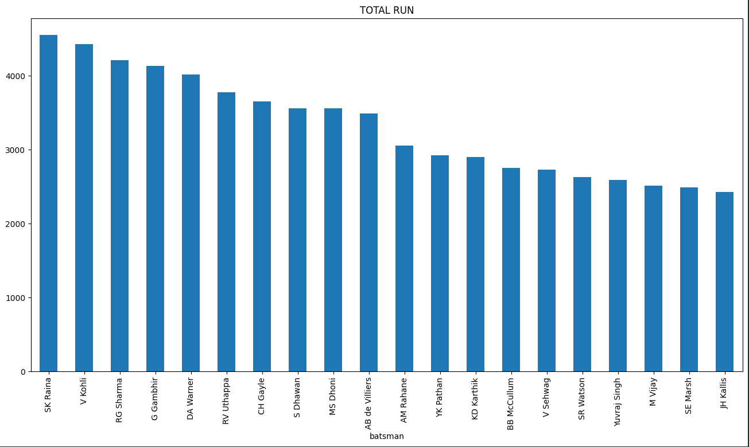
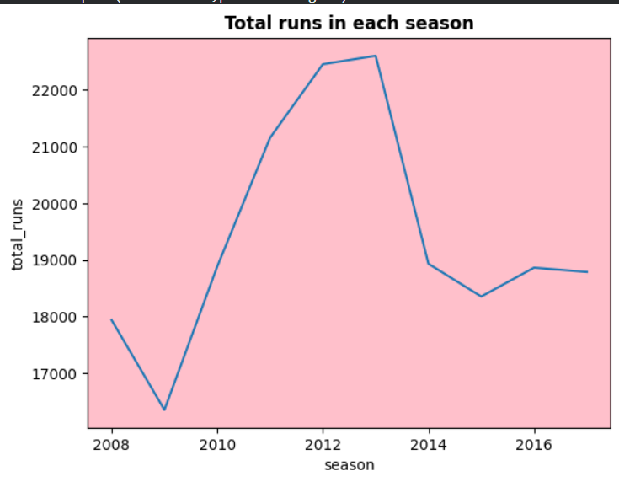
To make the analysis more meaningful, new derived metrics were created. These included total runs scored by each player, bowling contributions, strike rates, averages, and season-wise totals. Generating these additional features helped uncover patterns that were not obvious from the raw data.
Overall, the preprocessing stage transformed the original data into a much cleaner and well-organized version. With missing values handled, data types corrected, redundant fields removed, and new features added, the dataset became reliable and ready for the main analysis phase.
⭐ Methodology and Exploratory Data Analysis
After preparing and cleaning the dataset, the next step of the project involved understanding how the information was structured and what patterns could be discovered from it. This stage, which combines the methodology and the exploratory data analysis (EDA) process, helped guide the flow of the entire project and set the direction for deeper visualizations and insights.
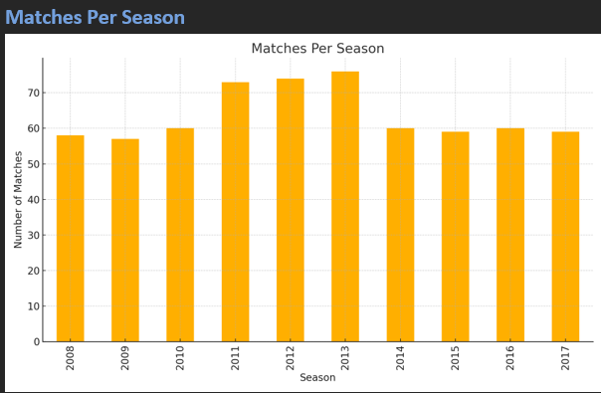
The process began by loading both datasets—matches.csv and deliveries.csv—into Python using Pandas. Once the data was successfully imported, I spent time exploring its shape, column descriptions, and basic statistics. This initial exploration allowed me to understand what kind of information was available, how detailed the ball-by-ball data was, and how the match-level dataset complemented it. I used this understanding to plan how to calculate player statistics, team performance metrics, and seasonal trends.
After familiarizing myself with the structure, I moved forward by performing data cleaning and preprocessing. This involved fixing missing values, converting column types, removing unnecessary fields, and merging datasets where deeper analysis was needed. With a clean dataset ready, I started exploring the data in a more intuitive way. EDA helped me discover which teams played the most matches, which players consistently performed well, how many matches were held each season, and what types of dismissals were most common across the IPL.
As I continued the analysis, grouping and filtering operations became an essential part of the methodology. Grouping the data by batsman, bowler, team, venue, and season helped extract meaningful statistics such as total runs scored, wickets taken, win counts, and match distributions. These early observations played a key role in shaping the later stages of the project, guiding which graphs to create and what relationships to study further.
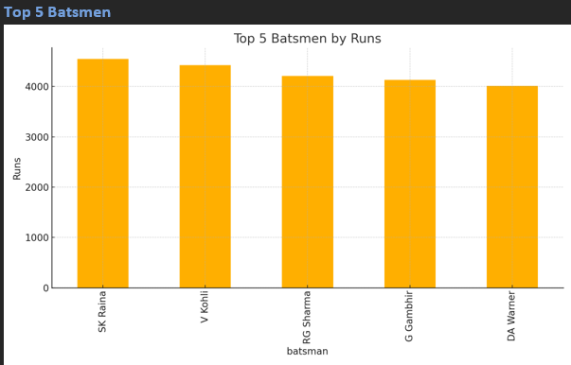
EDA also acted as an important checkpoint. It helped verify that the dataset was correctly cleaned, that the totals seemed realistic, and that no unexpected values or inconsistencies were present. Through this process, I developed a deeper understanding of the dataset’s story—how scoring patterns changed across seasons, how different teams performed over the years, and how various match conditions influenced outcomes.
In summary, the methodology and exploratory data analysis together formed the foundation of this project. By combining data loading, cleaning, feature preparation, grouping, and early pattern discovery, this stage allowed me to develop a strong understanding of the IPL dataset before moving into detailed graphs, visualizations, and final insights.
IPL Summary Report
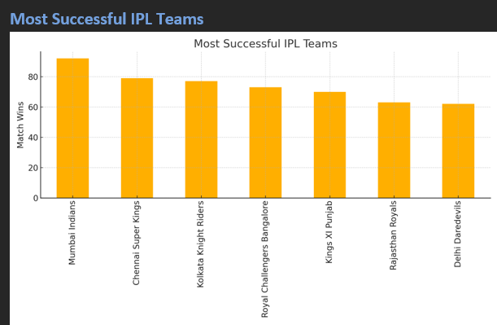
The IPL dataset tells a fascinating story when observed through the lens of statistics and visual exploration. One of the first insights that emerges is the identity of the league’s most successful team—determined by the highest number of match wins. This team has shown remarkable consistency across seasons, setting a high standard for performance.
When looking at batting achievements, a few standout players have accumulated exceptionally high run totals over the years. These batsmen have played crucial roles for their teams, often steering matches with their consistent scoring ability. Similarly, the distribution of dismissals across the IPL reveals the nature of the fast-paced T20 format. As expected, “caught” remains the most common mode of dismissal, reflecting aggressive batting strategies and high-risk gameplay.
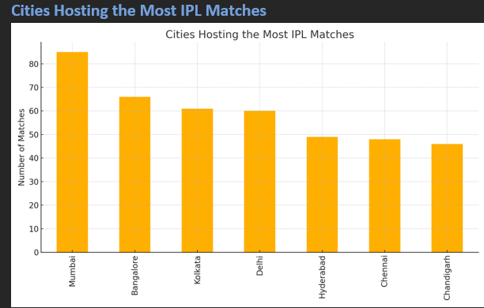
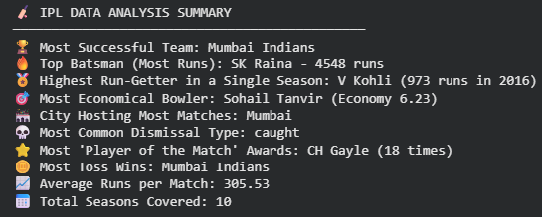
The analysis also highlights the cities that have hosted the most IPL matches. These venues form the backbone of the tournament and often create unique playing conditions that influence match outcomes. By studying the cities
that appear most frequently, we gain an understanding of where the IPL has built its strongest presence.
Overall, this summary captures the competitive essence of the IPL—showcasing team dominance, batting brilliance, venue patterns, and wicket behavior. Through visual exploration, the data brings the story of the IPL to life, showing how teams and players have shaped the tournament over the years.

⭐ Conclusion
This project provided a meaningful and data-driven look into the Indian Premier League by exploring both match-level and ball-by-ball information. Working with the dataset made it clear how rich and detailed IPL statistics are, and how many interesting stories the numbers can tell when they are organized and visualized properly. Through systematic cleaning, preprocessing, exploratory analysis, and graphical interpretation, the project transformed raw cricket data into understandable insights about players, teams, and match dynamics.
The analysis highlighted several important patterns such as the dominance of certain teams across seasons, the consistency of top run-scoring batsmen, and the nature of dismissals in high-pressure T20 cricket. It also revealed how venues, match counts, toss decisions, and individual contributions shape the overall flow of the tournament. More than just charts and tables, the project offered a deeper appreciation of how strategy, performance, and conditions intersect in the IPL. Overall, this project not only strengthened the understanding of Python-based data analysis but also demonstrated how sports data can be converted into meaningful knowledge.
However, like any data-driven work, this project also has a few limitations. The dataset contains some missing values and inconsistencies, especially in columns such as city names and umpire information, which may slightly affect certain insights. The project focuses mainly on historical data analysis and does not include machine learning predictions or advanced statistical modeling. Due to time and scope constraints, player-specific advanced metrics such as form analysis, pressure situations, and over-by-over momentum tracking were not explored in depth. Additionally, the dataset used ends at certain seasons and does not include the most recent IPL years, which could have provided even richer conclusions.
Even with these limitations, the project lays a strong foundation for future improvements. In future work, machine learning models can be introduced to predict match winners, forecast player performance, and analyze team strategies more accurately. A real-time dashboard using Power BI or Tableau could be created to make the insights interactive and visually engaging. More features such as win probability, match simulation, and comparison tools can also be added to make the analysis more comprehensive. Expanding the dataset to include recent IPL seasons and integrating player auction data, salary information, or live match feeds can further enhance the analytical depth.
In summary, while the project successfully uncovers meaningful patterns within the IPL dataset, it also opens doors to many exciting possibilities. With additional techniques and broader datasets, this analysis can evolve into a powerful tool for fans, analysts, and teams to understand the game at an even deeper level.

⭐ REFERENCES
[1] Kaggle, “IPL Complete Dataset (2008–2020).” [Online]. Available: https://www.kaggle.com/datasets
[2] ESPN Cricinfo, “Match and Player Statistics for Indian Premier League.” [Online]. Available: https://www.espncricinfo.com/
[3] W. McKinney, Python for Data Analysis: Data Wrangling with Pandas, NumPy, and IPython. O’Reilly Media, 2017.
[4] Matplotlib Documentation, “Visualization with Python.” [Online]. Available: https://matplotlib.org/stable/
[5] Seaborn Documentation, “Statistical Data Visualization.” [Online]. Available: https://seaborn.pydata.org/
[6] IPLT20, “Official IPL Website – Fixtures, Teams, and Match Summaries.” [Online]. Available: https://www.iplt20.com/

